Part Number: PU060-12114-P1

PU060-12115-P1

Kit Contents
Item # | Quantity Reqd. | Description
1 | 1 | Front Passenger Side Splashguard
2 | 1 | Front Driver Side Splashguard
3 | 1 | Rear Passenger Side Splashguard
4 | 1 | Rear Driver Side Splashguard
5 | 1 | Hardware Kit
6 | 1 | Instruction Sheet (Electronic Copy)
Hardware Bag Contents
Item # | Quantity Reqd. | Description
1 | 2 | M5 x 20 mm Screws
2 | 4 | #14 X 19mm Screws
3 | 6 | M5 Spring Clips (small)
4 | 6 | M5 x 15mm Screws
5 | 4 | #14 x 19mm Hex Screws
6 | 2 | M5 Spring Clips (large)
Additional Items Required For Installation
Item # | Quantity Reqd. | Description
1
2
3
Conflicts
Ground effects
Recommended Tools
Personal & Vehicle Protection | Notes
None
Special Tools | Notes
None
Installation Tools | Notes
Screwdriver | Phillips #2, #3
Socket & Driver | 10mm (3/8”)
Clean Cloth/Rag
Drill | 90 ° / 45 °
Drill Bit | 6mm (1/4”)
Torque Wrench | 0-100 ft-lbf
Special Chemicals | Notes
Cleaner | VDC Approved Cleaner

General Applicability
All Models
Recommended Sequence of Application
Item # | Accessory
1
2
3
*Mandatory
Vehicle Service Parts (may be required for reassembly)
Item # | Quantity Reqd. | Description
1
2
3
Legend
STOP: Damage to the vehicle may occur. Do not proceed until process has been complied with.
OPERATOR SAFETY: Use caution to avoid risk of injury.
CAUTION: A process that must be carefully observed in order to reduce the risk of damage to the accessory/vehicle and to ensure a quality installation.
TOOLS & EQUIPMENT: Used in Figures calls out the specific tools and equipment recommended for this process.
REVISION MARK: This mark highlights a change in installation with respect to previous issue.
SAFETY TORQUE: This mark indicates that torque is related to safety.

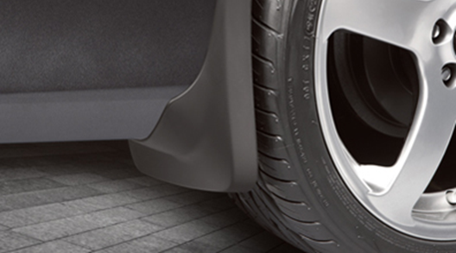

Care must be taken when installing this accessory to ensure damage does not occur to the vehicle. The installation of this accessory should follow approved guidelines to ensure a quality installation.

These guidelines can be found in the "Accessory Installation Practices" document.

This document covers such items as:-
- Vehicle Protection (use of covers and blankets, cleaning chemicals, etc.).
- Safety (eye protection, rechecking torque procedure, etc.).
- Vehicle Disassembly/Reassembly (panel removal, part storage, etc.).
- Electrical Component Disassembly/Reassembly (battery disconnection, connector removal, etc.).

Please see your Toyota dealer for a copy of this document.

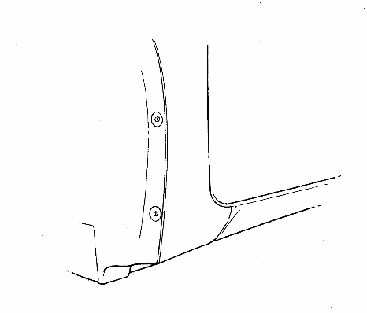
- Clean Front Mounting Area
Fig. 1-1
Area to be cleaned
  - Clean and degrease front body panel where splash guard is to be located with a clean cloth and VDC approved cleaner (Fig. 1-1).
- Installation of Front Splash Guard
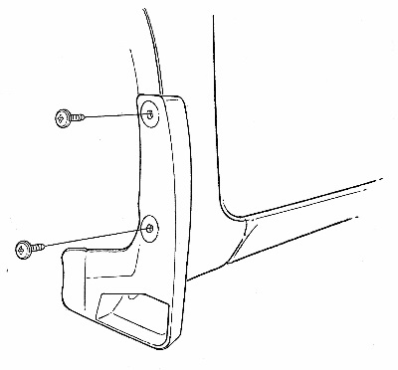
(a) Mount splash guard on body panel and install supplied #14 screw in location B while holding part up and into body panel, then tighten (Fig. 2-1).
#3 Phillips Screwdriver
Supplied
#14 Screws
A
B
Splash guard
Fig. 2-1
Do Not Over Tighten.
  - Install supplied #14 screw in location A while holding part up and into body panel, then tighten (Fig. 2-1). Do Not Over Tighten.
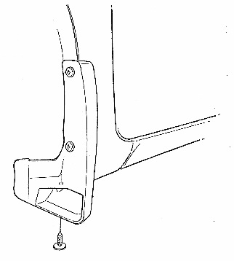
  - Install supplied #14 hex screw in location C while holding part up and into body panel, then tighten (Fig. 2-2).
Supplied #14 Hex screw
C
10mm Socket/Driver
#3 Phillips Screwdriver
Fig. 2-2
Do Not Over Tighten.
  - Repeat procedure for other side.

Clean Rear Mounting Area and Remove Wheel
NOTE: REMOVAL AND REINSTALLATION OF REAR WHEELS IS REQUIRED TO DRILL PANEL EDGE ATTACHMENT HOLES UNLESS A SIDE-ANGLE DRILL IS USED.
        - Clean and degrease rear bumper panel where splash guard is to be located with a clean cloth and VDC approved cleaner.
        - If straight and accurate holes cannot be drilled, support the vehicle and remove the rear wheel. Follow the Owner’s Manual procedure.

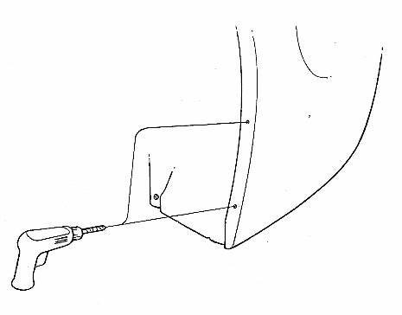
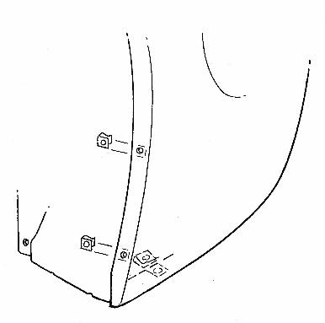
Hole Preparation and Clips
Fig. 4-1
Drill / 6mm Drill Bit

B
6mm Bit

A
Drill
Fig. 4-2
C
Supplied Spring Clips
(small)
B
A
Supplied Spring Clip
(large)
  - Drill 6mm (1/4”) holes in panel edge at dimple locations A and B (Fig. 4-1).

  - Install supplied spring clips (small) over panel edge holes locations A and B with turned up edge on inside of panel (Fig. 4-2).
  - Install supplied spring clip (large) over panel edge hole location C with turned up edge on inside of panel (Fig. 4-2).

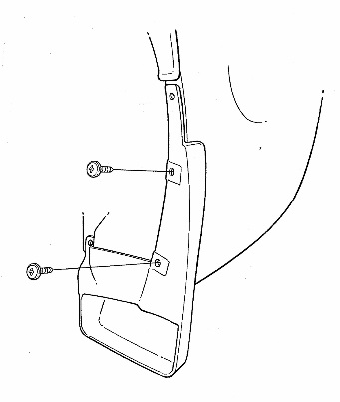
Installation Of Rear Splash Guard
#2 Phillips Screwdriver
B
Splash guard
Supplied
M5 x 15mm
Screws
A
Fig. 5-1
(a)
Mount splash guard and install M5 screw 15mm in location B then A while holding part up and into bumper panel and tighten (Fig. 5-1).

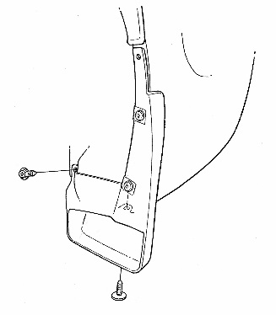
#3 Phillips Screwdriver
10mm Socket/Driver
Supplied
#14 x 19mm
Hex Screw
Supplied
M5 x 20mm screw
C
D
Fig. 5-2
  - Install supplied M5 screw 20 mm in location C while holding part up and into bumper panel and tighten (Fig. 5-2).
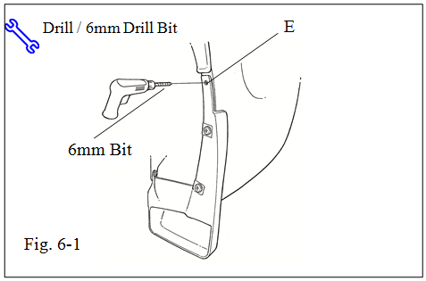
  - Install supplied #14 hex screw in location D while holding part up and into bumper panel and tighten (Fig. 5-2).
Fig. 5-3

  - Using part as a template hold tight to panel and drill 6mm ( 1/4 “) hole through panel edge and liner at location E (Fig. 5-3).

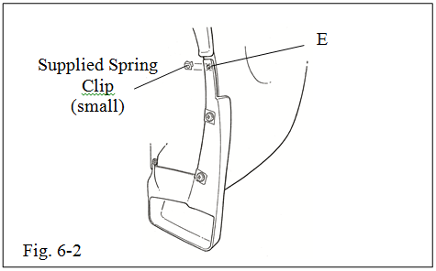
Fig. 5-4
  - Install supplied spring clip (small) over panel edge hole with turned up edge on inside of panel and between liner at location E (Fig. 5-4).

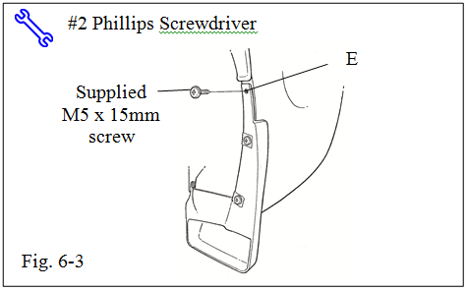
Fig. 5-5
  - Install supplied M5 screw 15mm in location E and tighten (Fig. 5-5).
  - If the wheel was removed Step 3 (b), reinstall it now and torque the lug nuts to 103 N∙m (76 ft∙lbf).

Torque: 103 N∙m (76 ft∙lbf)
  - Repeat procedure for other side.

Accessory Function Checks
Gaps between mudguards and body side
Inspect torques

Vehicle Appearance Check
After accessory installation and removal of protective cover(s), perform a visual inspection.

Excessive gaps greater than 1.0 mm.
If the wheels were removed, torque the lug nuts to 103 N•m (76 ft•lbf).

Ensure no damage (including scuffs and scratches) was caused during the installation process.
(For PPO installations, refer to TMS Accessory Quality Shipping Standard.)

